**FAMU-FSU College of Engineering   
Department of Electrical and Computer Engineering**

**EEL4911C – ECE Senior Design Project I**

**CONCEPTUAL DESIGN REVIEW**

Project title: **SAE Formula Electric Racer**

Team #: 3

Student team members:

- Aldreya Acosta, Industrial Engineering (Email: [aa09c@fsu.edu](mailto:aa09c@fsu.edu))

-Tomas Bacci, Mechanical Engineering (Email: [teb08@fsu.edu](mailto:teb08@fsu.edu))

- Danny Covyeau, Electrical Engineering (Email: [dc08k@fsu.edu](mailto:dc08k@fsu.edu))

-Scott Hill, Electrical Engineering (Email: [sbh09d@fsu.edu](mailto:sbh09d@fsu.edu))

-Stephen Kempinski, Mechanical Engineering (Email: [smk09f@fsu.edu](mailto:smk09f@fsu.edu))

- Ryan Luback, Industrial Engineering (Email: [rll07d@fsu.edu](mailto:rll07d@fsu.edu))

-George Nimick, Mechanical Engineering (Email: [gan07@fsu.edu](mailto:gan07@fsu.edu))

-Sam Risberg, Mechanical Engineering (Email: [sjr07c@fsu.edu](mailto:sjr07c@fsu.edu))

- Corey Souders, Industrial Engineering (Email: [cls07n@fsu.edu](mailto:cls07n@fsu.edu)

Senior Design Project Instructor:

**Dr. Michael Frank**

**Dr. Hui Li**

**Dr. Patrick Hollis**

**Dr. Chiang Shih**

Submitted in partial fulfillment of the requirements for

EEL4911C – ECE Senior Design Project I

December 1, 2011

# Executive Summary

This project's initiative is to design a Formula race vehicle using hybrid or electric technology. The sales group that this will be marketed for is the non-professional weekend autocross competitor. The design of this project will be centered on the intended sales group as well as focusing on the goal of making this easy to manufacture. The vehicle’s design and performance will be evaluated at an international competition hosted by the Society of Automotive Engineers (SAE). At this competition, there will be two main categories that of judging that the vehicle will undergo, which are the static and dynamic events. The static portion of the event will involve design review of the vehicle and the accuracy of the build compared to the design. This event will also review the safety of the vehicle, which is required before moving on to the dynamic portion of the competition. The dynamic event is subdivided into a three subcategories: acceleration, autocross and endurance. These subcategories are selected to test the individual systems of the vehicle to their extreme. The performance of the vehicle should reflect the performance of each system of the vehicle and the vehicles will be ranked accordingly. There are three major judging categories to compete in, which are Hybrid-In-Progress, Electric, and Hybrid. Hybrid in progress is basically an all electric category that is meant for first year teams that have the intention of doing a hybrid car in two years. There is also the actual hybrid category that includes vehicles that have implemented a combined system of an electric motor and an internal combustion engine. The electric category is new this year that involves vehicles that will only perform using an electric motor.

The vehicle being designed will be separated into two major systems: mechanical and electrical. All systems will be design using the constraints included in the rules document provided by the judges. The mechanical system will consist of four primary categories that will include, steering, suspension, braking, and chassis. The design approach will be discussed in more detail below, however the essential goal that is sought in all of them is effectiveness, lightweight, durability, functionality, and integration. For example, the chassis needs to provide a platform for all the systems to connect and at the same time provide a structure that houses and protects all of its components. Ideally, this should not be overdone and it should be optimized to reduce weight for the increase in performance. The electrical section is designed in a similar matter, in terms of optimization and inter-compatibility with the other systems.

The electrical section is subdivided into two primary categories, which are battery management and motor design. The motor controller, which controls the operations of the electric motor, must be able to handle varying inputs from the accelerator pedal and properly regulate energy from the batteries to propel the car. The electrical motor must be powerful enough for the car to complete the electric acceleration test. Efficiency and power output are of great importance for the electric motor. The accumulator must be compact, lightweight, and be able to robustly handle high g-forces and multiple high power discharges to successfully complete the competition.

# Table of Contents

Executive Summary ii

Table of Contents iii

1 Introduction 1

1.1 Acknowledgements 1

1.2 Problem Statement 1

1.3 Operating Environment 1

1.4 Intended Use(s) and Intended User(s) 1

1.5 Assumptions and Limitations 2

1.6 Expected End Product and Other Deliverables 2

2 System Design 3

2.1 Overview of the System 3

2.2 Major Components of the System 1

2.2.1 High Voltage Accumulator 1

2.2.2 Battery Management System 1

2.2.3 Charging Circuit 1

2.2.4 Ground Fault Detection 1

2.2.5 Low Voltage Accumulator 1

2.2.6 Motor 2

2.2.7 Controller 3

2.2.8 Chassis 3

2.2.9 Suspension 4

2.2.10 Braking System 5

2.2.10.1 Brake Calipers, Rotors and Pads 5

2.2.10.2 Brake Lines and Fluid 5

2.2.10.3 Brake Master Cylinder, Pedal, and Brake Bias Adjuster 5

2.2.11 Steering 6

2.2.11.1 Rack and Pinion 6

2.2.11.2 Steering Joints and Wheel 7

2.3 Performance Assessment 7

2.3.1 Battery System and BMS 7

2.3.2 Motor and Controller 7

2.3.3 Chassis 8

2.3.4 Suspension 9

2.3.5 Braking System 9

2.3.6 Steering 9

2.4 Design Process 9

2.4.1 High Voltage Accumulator 9

2.4.2 Battery Management System 10

2.4.3 Motor and Controller 10

2.4.4 Chassis 10

2.4.5 Suspension 10

2.4.6 Braking 11

2.4.7 Steering 11

3 Design of Major Components 12

3.1 Battery System 12

3.2 BMS Configuration 15

3.3 Ground Fault Detection 17

3.4 Charging System 18

3.5 Low Voltage Accumulator 18

3.6 Motor Controller 18

3.7 Optoisolator Circuit 19

3.8 Chassis 20

3.9 Suspension 22

3.10 Braking 26

3.11 Steering 27

4 Schedule 1

5 Budget Estimate 1

6 Overall Risk Assessment 3

6.1 Technical Risks 3

6.1.1 Technical Risk 1: Meeting Competition Guidelines 3

6.1.2 Technical Risk 2: Failures of Safety 4

6.1.3 Technical Risk 3: Supplier Specifications for Components 5

6.2 Schedule Risks 5

6.2.1 Schedule Risk 1: Full Completion of the Vehicle 5

6.2.2 Schedule Risk 2: Receiving Parts 6

6.2.3 Schedule Risk 3: Obtaining Funding 7

6.2.4 Schedule Risk 4: Changes in the Design 7

6.3 Budget Risks 8

6.3.1 Budget Risk 1: Overextension 8

6.3.2 Budget Risk 2: Hidden Costs 9

6.3.3 Budget Risk 3: Component Failures 9

6.4 Summary of Risk Status 10

7 Conclusion 11

Appendices (optional) 13

# Introduction

## Acknowledgements

The SAE Formula Electric Team would like to extend their gratitude for the monetary contributions made by the FAMU-FSU College of Engineering Dean’s Office, along with the contributions made by the College’s Mechanical Engineering, Industrial Engineering and the Electrical Engineering Departments. Their monetary contributions, as of this moment, are the sole source of funding for this project. The team would also like to acknowledge the assistance and guidance provided by the College’s faculty, especially Dr. Patrick Hollis and Dr. Hui Li, as well as the College’s chapter of the Society of Automotive Engineers for their contribution of resources and advice, notably Anthony Sabido. The team would also like to thank Nathan Scott for his help on the design of the electrical portion of the project

## Problem Statement

A student conceived, single driver, formula all electric racecar is to be designed and fabricated with the intent of competing with it in the 2012 Formula Hybrid competition. The design’s tough-est challenge will be to make sure it abides by all competition rules. These rules place many re-strictions on areas like chassis designs, braking systems, and accumulator size that must be carefully considered. The vehicle will be designed as a prototype of a compact, agile car that should appeal to the average non-professional weekend autocross competitor. Since it is competing under the all-electric category the vehicle will use batteries as its energy source (no ICE). The car must be safe to operate and be equipped with multiple safety and emergency features.

## Operating Environment

The operating environment that the team will design for will be a flat racing track or drag strip such as the New Hampshire Motor Speedway where the competition will take place. The vehicle will be driven and tested out in parking lots prior to competition for tuning purposes, but the main goal will be for it to complete the acceleration and endurance events at competition grounds. The vehicle needs to be water-resistant enough to operate during rainy conditions as well. Safety is a major concern since the vehicle will be competing in a racing environment where a crash is always possible.

## Intended Use(s) and Intended User(s)

The vehicle is meant to be designed for the non-professional weekend autocross competitor. However, the main intended users for our specific prototype will be team members as well as any competition representatives. The vehicle must be designed to accommodate drivers from the 95th percentile of men (max) to the 5th percentile of women (min). For team members to be able to race at competition they will need to provide a valid driver’s license, provide proof of insurance, and be capable of handling and controlling the vehicle at high speeds. Additionally anyone driving the car will be wearing protective equipment (suit, helmet, gloves).The vehicle will be used to compete at the 2012 Formula Hybrid competition under the all-electric category.

## Assumptions and Limitations

**Assumptions:** The following assumptions were made by the design team in regard to the project. The vehicle is being designed to compete in a closed track environment, therefore it will be opti-mized for flat solid surfaces and not hilly or off-road courses. The team will have some vehicle parts and materials donated to them, and they will function correctly. The car is being designed for daytime use as the group will not focus on components such as lights or reflective panels for night time visibility. The team entire team will travel to Loudon, New Hampshire for the competition event in late April.

**Limitations:** The major limitations of this project are embedded in the 2012 competition rules. One of these is a limit on the accumulator system of 5,400 Wh or max price of $7,200. The vehicle must complete a 75 meter stretch in less than 10 seconds as a minimum completion requirement. The roll hoops on the chassis must be made from one continuous tube (no welds). The car needs to be able to seat people from the 95th percentile of men to the 5th percentile of women. The braking system must apply force and be able lock up every wheel, successfully stopping the vehicle. The suspension system must keep the vehicle with at least an inch of clearance with the road, and must provide the wheels with at least 2 inches of wheel travel. With the exception of minor tuning and aesthetic features, the project must be completed by mid April as the competition begins on April 30th 2012. The project must be funded and completed with the allotted budget.

## Expected End Product and Other Deliverables

The end product will be an all electric, compact, single driver vehicle that is agile and fun to drive. The vehicle will be energy efficient and be able to participate competitively in local race tracks. The batteries will be included with the vehicle and will be recharged on board, from any standard household outlet.

# System Design

## Overview of the System

The design being proposed is that for a competition being hosted by the Society of Automotive Engineers under the Formula Hybrid Student Design Competition. It was agreed upon to design for the fully electric category and, thus, the component break down will reflect this decision. Although the vehicle will be fully electric, there will be several mechanical components, as well as electrical ones. Mechanical systems on this vehicle will include systems such as braking, suspension, chassis, steering and power train. The electrical systems will include the electric motors for each wheel, the controllers and their subcomponents, as well as a battery management system.

This design is a vision of the end product that this team feels is tangible in terms of design, feasibility and monetarily, using our proposed budget. However, this will be contingent upon the amount of funds that will be allotted to us and will change our design accordingly. For instance, a increased budget may change the vehicle by monetarily permitting a two motors and better vehicle components, whereas our current monetary allotment would only permit us to use one motor and the same components used in previous years.

The budget is only one of many constraints placed on the vehicle. The majority of the constraints will be a result of the rules we must follow in order to participate in the competition. Al-though these rules lead many of the design systems in a particular direction, there is still enough freedom to develop a unique and effective design. One of the goals, however, is to improve upon the design from the past two years. This may involve optimizing the existing design or a complete redesign. Below are the two top level designs that illustrate the required components to make the vehicle function, as currently envisioned by our group of two electrical engineering students and four mechanical engineering students. Figure 1 is the top level design for the mechanical aspect.

The electrical system of the formula hybrid car is laid out as seen in the top level electrical diagram in Figure 2. This system consists of a high voltage battery pack that sends current to the motor controller which uses high power MOSFETs to properly control the motor. The low voltage battery pack is used for all of the circuitry that enters the cabin area and is used for powering things like the contactors. All low voltage systems that communicate with high voltage systems are isolated as required by the 2012 Formula SAE Hybrid rules.

Figure : Mechanical Top Level Design

Throttle Control

Brake Pedal

Brake Fluid Reservoir

Brake Master Cylinder

Steering Rack & Pinion

*Figure 2: Electrical Top Level Design*



## Major Components of the System

### High Voltage Accumulator

The high voltage accumulator will be the main means of powering the electric motor of the vehicle. It is being designed at 72V and 30Ah of capacity. Chapter 3 goes into more a more detailed breakdown of comparisons between different battery types. The type of battery that will be used for our design is the Turnigy 3.7V 5Ah Lithium polymer battery. It is shown in chapter 3 that it is best suited for the application that we are designing for.

### Battery Management System

Since lithium polymer batteries are extremely volatile the BMS of the vehicle is a very important component of the system. If the batteries are overcharged or over-discharged or the temperature is allowed to get to hot then the batteries can explode in a ball of fire. The BMS takes constant readings of the voltage and temperature of the batteries and turns off charging to a part of the battery circuit if it determines that the voltage is nearing upper or lower bounds and it also checks the temperature to make sure the battery is not getting too hot.

### Charging Circuit

The charging circuit for the vehicle allows for the team to recharge the batteries once they have been used for a distance. Calculations for charging time are included in chapter 3.

### Ground Fault Detection

The ground fault detection circuit of the vehicle ensures that the high voltage circuit will not energize the frame of the vehicle. If the frame of the vehicle was energized then the driver of the vehicle or anyone in contact with it could be in extreme danger and could even be killed. The ground fault detection circuit is wired in series with the big red buttons on the vehicle and creates an open circuit if a certain voltage is read between the frame of the vehicle and the high voltage accumulator.

### Low Voltage Accumulator

The low voltage accumulator will be used to power all of the components of the vehicle that are not used to propel the vehicle. This includes but is not limited to Electrical control unit (ECU), fault detection circuit; BMS master board, rpm sensors and may other things. Since this accumulator is a low voltage of only 12V it will be grounded to the frame of the vehicle.

### Motor

The Motor is an Agni 95R permanent brushed DC motor. The motor peaks at 93% efficiency. It can output approximately 22 kW continuously as well as 42 Nm of torque (continuously). It also weighs a mere 24 pounds and is a popular option among other formula hybrid teams. Below is a graph from Agnimotors.com showing the performance curves of the motor at our intended voltage level.

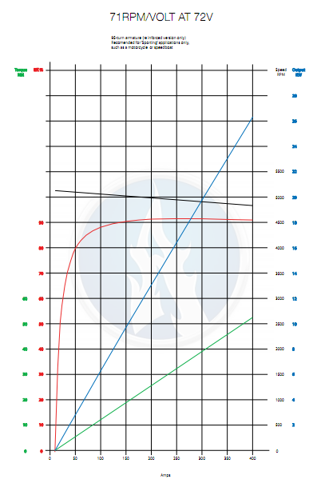

Figure : Performance Curve of Agni Motor

### Controller

The controller to be used is the Kelly KD72501. This controller uses high power MOSFETs to achieve 99% efficiency in most cases according to Kelly Controls, LLC. The motor has a continuous current rating of 200 amps and can handle 500 amps for one minute which is perfect for allowing our car to let loose during long straightaways.

The controller also has a built in regen feature that allows the motor to be used as a generator during braking to allow the kinetic energy of the vehicle to be recaptured and stored back in the batteries. This feature is not a replacement for mechanical brakes due to competition rules. It is also not as effective as mechanical brakes as it can only recapture 100 amps peak. This gives a peak reward torque at the motor of 10.5 Nm which is not enough to quickly bring the vehicle to a standstill as desired in a performance vehicle.

The controller is also programmable through Kelly’s free user-friendly GUI. Through this feature the peak current, minimum high voltage level and other parameters can be set to help protect the vehicles vital components.

### Chassis

The chassis is basically one unified structure that serves several different purposes. Although it is possible for the chassis to be comprised of several separate parts, our team has decided that the best and most effective chassis will consist of several frame members that are welded together. These individual frame members, along with the tabs and other mounting points are the major physical components of the chassis. The chassis as a whole is also segregated in the 2012 Formula Hybrid Rules document into sections regarding required characteristics. These sections are as follows: main roll hoop, front roll hoop, roll hoop bracing, roll hoop bracing supports, front bulkhead, side impact structure, and impact attenuator. Each are given specified characteristics and minimum specifications. All definitions are provided in the Rules document, but are also listed as follows and can be seen in Figure 4 below:

**Main Roll Hoop** – A roll bar located behind the driver’s torso.

**Front Roll Hoop** – A roll bar located above the driver’s legs.

**Roll Hoop Bracing** – Frame members that provide support for the main roll hoop and the front roll hoop

**Roll Hoop Bracing Supports** – The structure from the lower end of the roll hoop bracing connecting back to the respective roll hoop.

**Front Bulkhead** – A planar structure that defines the forward plane of the major structure of the frame and functions to provide protection for the driver’s feet.

**Side Impact Structure –** The area of the side of the car extending from the top of the floor to the 350mm or 13.8 inches above the ground and from the front hoop back to the main hoop

**Impact Attenuator –** A deformable, energy absorbing device located forward of the Front Bulkhead.

I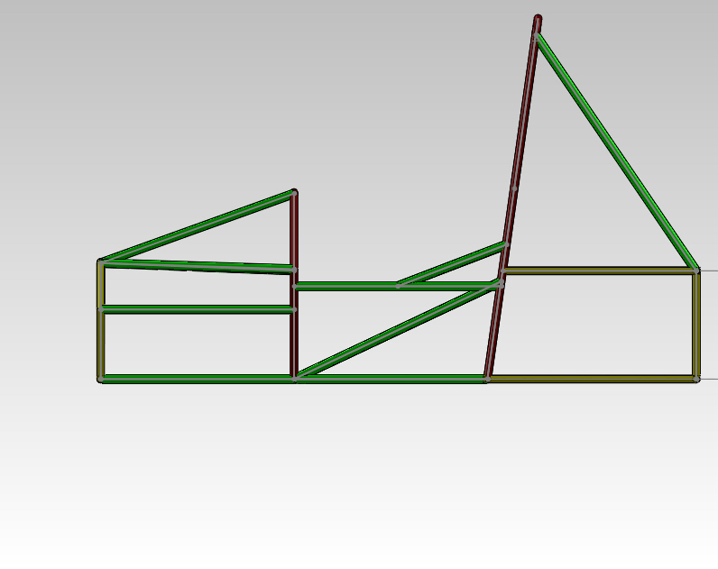

Bracing Support

Main Hoop

Front Bulkhead

Front Hoop

Main Hoop Bracing

Side Impact Structure

Figure : Sections of the Chassis

### Suspension

The suspension system will connect the vehicle’s sprung and unsprung weight (wheels to chassis) and allow the driver to maintain traction and stability while cornering or accelerating. The suspension geometry uses a multi-link independent set up for each of the wheels on the vehicle. The suspension is being designed to provide maximum traction and stability by limiting toe in the wheels and providing negative camber gain with rising wheel travel. The front of the vehicle will use double wishbones with pull rods, and also have tierods to connect the steering. The rear will use double wishbones, pushrods, and an extra toe control link since the rear wheels won’t steer. In either case of the push or pull rod, the idea is to transfer the forces acting on a wheel to rise to a spring damper set up, allowing the wheel to maintain contact with the road and therefore better traction. Each wheel will have one degree of freedom in the vertical direction (jounce, rebound) by restricting the others with the five- link connection. The suspension will meet the requirements of the competition as it will have a wheelbase of 62 in, allow for 2 inches of travel (1 in jounce, 1 in rebound), and suspend the car over 1 in at all times.

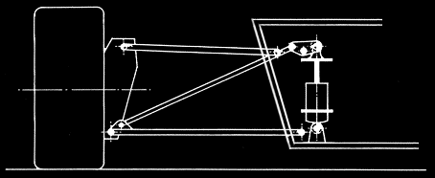

Figure : Push rod configuration example. A bell crank transfers tire forces traveling through the push rod to a spring dampener.

### Braking System

#### Brake Calipers, Rotors and Pads

The most fundamental part of the braking system is the calipers, rotors and pads. Once the pressure is sent though the lines the calipers compress pads that eventually contact the rotors and slow the rotation of the wheel which is rigidly connected to the wheel. The pad and rotor are bout metal, but the pads are semi-metallic or possibly ceramic which is a softer metal then the steel rotor so the pads will slow the rotor down with pressure and friction.

#### Brake Lines and Fluid

Before the brake pad compresses on the rotor the brake lines have to sent fluid to the caliper. Once the fluid is forced into the caliper the piston inside the caliper is forced away from the center and pushes out into the rotor with the pad between the piston and rotor.

#### Brake Master Cylinder, Pedal, and Brake Bias Adjuster

Even before the brake lines send fluid to the caliper the brake master cylinder must be compressed. This is accomplished by pushing a pedal which has a pivot point that allows for much more force to be seen at the master cylinder as opposed to the pedal. When the cylinder is compressed the fluid can then compress the caliper. We have decided to use a brake bias adjuster this will allow an adjustment in brake pressure for the front and rear.

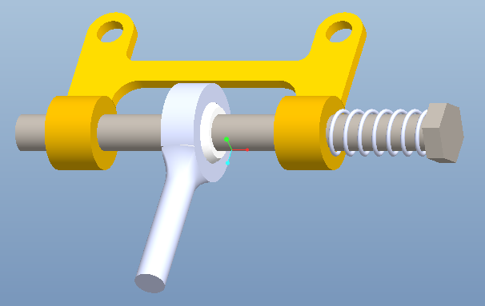

Figure : Brake Bias Bar

### Steering

#### Rack and Pinion

Steering is a simple rotational movement made by the hands into a turning motion of the wheel. In most cases this transfer of motion is easily attainable with proper hardware and gears. A simple worm gear could be used in a toy car for example. When you have a massive weight on the front of the vehicle like a production car, turning the wheel is very tough or impossible. The design proposed does not have this issue as it is rear wheel driven, and therefore simple rack and pinion with reverse ackerman geometry has been selected.. The car doesn’t weigh a large enough amount to need power steering so we will use a dry rack and pinion in front of the front wheel axle axis.

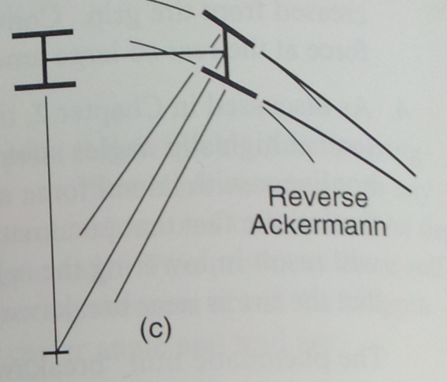

Figure : Showing the attributes of Reverse- Ackerman steering

#### Steering Joints and Wheel

The steering joints needed are mostly heim joints which allow as much movement as their casing will allow. This is idea for the steering rods that move very little during cornering, but need a seamless transition none the less.

## Performance Assessment

### Battery System and BMS

This system will meet the needs and requirements for the project by following the rules of the formula hybrid competition. This system will also meet the needs and requirements of the project by allowing the vehicle to finish the endurance competition without running out of energy since it is weighted the highest of the dynamic competitions.

### Motor and Controller

The motor puts out 42 Nm of torque consistently from about 0 to 50 mph. Assuming a gear reduction of 4.5:1 this results in 189 Nm of torque at the rear wheel through our differential.

The chart below depicts common coefficients of friction between a tire and asphalt. 0.9 represents a tire similar to a racing slick that has a lot of grip. 0.5 and 0.8 represent coefficients that can be expected from a typical street tire. 0.1 represents a tire in contact with a wet road. We want these torque ratings to meet or exceed the peak torque at the rear wheels so that the wheels don’t spin under hard acceleration. As can be seen from Table 1, as long as the track is dry the motor should perform well.

Table : Peak Torque at Differing Coefficients of Friction

|  |  |  |  |
| --- | --- | --- | --- |
| CF | Mass Over Rear Axle (assuming 50:50 weight distribution) | Wheel Radius, r | Peak torque before tire slips  τ = M*g*r*CF |
| 0.9 | 150 kg | 0.254 m | 336 Nm |
| 0.8 | 150 kg | 0.254 m | 299 Nm |
| 0.5 | 150 kg | 0.254 m | 187 Nm |
| 0.1 | 150 kg | 0.254 m | 37 Nm |

Due to a 4.5:1 gear ratio the top speed of the car cannot exceed 79.3 mph. This is due to the motor having a top speed of 6000 rpm at 72 volts. This speed is perfectly acceptable for the car as the top speed to be competitive in the endurance event of the competition is only 65.2 mph.

This motor is also capable of accelerating the car a distance of 75 meters from a standstill in less than 10 seconds as the competition rules require. Assuming 189 Nm of torque this equates to an acceleration of 2.48 m/s2. According to the formula,

$75 m=\frac{1}{2}*at^{2}$ $SEQ Equation \backslash * ARABIC$ $1$

the time to complete the acceleration run is 7.8 seconds. This is the approximate time that the 2010 FAMU-FSU Formula Hybrid team completed the acceleration event in with the same motor. Therefore we feel that this calculation along with the information above show that this motor is a suitable choice for our vehicle.

Depending on the high voltage accumulator’s size (which is only limited by the budget right now), the vehicle should have an excellent shot at completing the endurance event (22 km). The 2010 team completed the endurance event with the same motor, a heavier vehicle and a battery pack that had a max capacity of approximately 2220 Wh.

### Chassis

The chassis’ performance will be assessed in a few different manners, which will involve, comparison to the Rules document, comparison to the spatial and mounting requirements of various components, as well as some consideration for the ergonomics of the chassis in relation to the driver.

The first and foremost methods of assessment will be designated through the use of the Rules document to ensure that the chassis meets the required specifications to pass the technical inspection. This, however, will be a continuous process until the actual design is practically finalized and the Rules will then govern any final changes made to the chassis. In a practical sense, the fitment of components in regards to room and mounting will be assessed through 3-Dimensional modeling and ultimately assessed after the vehicle is built, with hopefully nothing more than minor changes needed. Essentially, the spatial requirements will govern a large portion of the design and the assessment of that portion of the design will be determined through the actual fitment.

### Suspension

The suspension will need to meet the requirements of the competition that are to have a wheelbase of over 60 in, allow for 2 inches of travel (1 in jounce, 1 in rebound), and suspend the car over 1 in at all times. The geometry decided upon will undergo simulations using ADAMS modeling software to ensure desired specifications are met. The wheelbase will be set by the attachment points from the control arms to the chassis. This will be verified to be above 60 inches. The control arms will be verified to allow for at least 2 inches of travel using ADAMS software, and will be verified by hand after attaching it to the chassis, prior to loading the springs.

### Braking System

The assessment of the braking performance in multiple real world scenarios will be performed. The first will be the visual test; when the brake pedal is pressed the calipers will have to compress the pads on the rotor. Next, we will raise the car and try to rotate the wheels while the pedal is engaged to ensure the wheels are locked. The second test is a real world braking stop test. Starting at low speeds we will test the functionality of the brakes. Eventually we will move to high speed braking to see the limitations of the tires and locking characteristics.

### Steering

To test steering performance, we can measure the angle difference in the front tires while the car is stationary. Still with the car stationary, we will lock the steering wheel all the way to the left then all the way to the right. If there is no binding, a slow speed skid pad will be set-up. With the wheel fully locked either left or right we will determine the steering circle the car follows and how many G’s the car outputs.

## Design Process

### High Voltage Accumulator

The design process for the selection of the high voltage accumulator is outlined in chapter 3. This design process entailed comparing three types of batteries for use in the high voltage accumulator. These three battery types were Lithium Polymer, LiFePO4 and regular Lead Acid batteries. Things such as energy density, power density, Wh per dollar, and Ah per dollar were taken into consideration when designing the High voltage accumulator. From these we have decided to go with the Lithium Polymer batteries

### Battery Management System

The battery management system on the vehicle was decided upon by contacting the companies that make the BMS to see what kind of pricing we could get and see what kind of wiring could be done with the battery system that we had in mind. Taking budget into account the team has decided to go with the Elithion BMS because the team already has a master board from past teams.

### Motor and Controller

The biggest decisions that have been made this far affecting the electrical system have been due to the limited amount of funding that the team has received this year. In order to pursue a lithium polymer battery system and a new bms system, the car’s design has been reevaluated several times to reduce costs. The car originally was a 4-motor design that placed one motor at each wheel. Each motor would then have an identical gear reduction to a drive shaft connected to the wheel. This was quickly determined to be too expensive and too complex to complete in a year so a two-motor approach was decided upon to reduce cost. These two motors would be run in series on a single controller, creating a differential effect on the rear wheels. After some time this was also determined to be an unreachable goal. The team has therefore chosen to go with a one motor, one controller design to save money. The motor and controller from the previous years’ team will be reused to give other team members more money for the areas of the vehicle that they’re focusing on. The motor and controller have been thoroughly reviewed to make sure they are still suitable for this year’s car.

### Chassis

The chassis is designed using the same guidelines through which it will be assessed therefore the design assessment ought to go fairly smoothly. The design begins by taking into consideration the major components of the vehicle in regards to how and where these will be fitted or mounted, with a general idea of the rules kept in mind. This allows for the preliminary shape of the vehicle to take place. The Rules document then takes a more significant role as certain aspects are governed by them, primarily for safety reasons, such as material properties, heights of bars and mounting requirements. These two are simultaneously considered throughout the entire design phase so that extra work is avoided from having to continuously redesign to satisfy both aspects. Once it appears that most aspects have been satisfied, everything is reviewed thorough to make any necessary changes, which is then followed by a finite element analysis (FEA). This is used to determine better placement of members, the removal or addition of frame members or as a justification or criticism of the wall thicknesses chosen.

### Suspension

The suspension design process involved accommodating an existing, yet flexible, chassis with a suspension that would meet specifications set forth by competition rules while providing good handling and stability to the vehicle. The type of suspension was determined to be multilink independent for the front and rear. The vehicle wheelbase was selected at 62 inches, close to the minimum of 60 since we have a relatively short chassis. The track lengths were decided upon once a wheelbase was set. Drawings that accounted for the front top and side views of the suspension arms were made for the front and rear in order to set the geometry of the control arms. This allowed for specific parameters to be designed for in different views. From the drawings an ADAMS suspension was built on the computer for analysis

### Braking

Initial design of the brake system will be simple with 3d Modeling and checking the see if there is proper clearance between all the parts. The only necessary parts that will have clearance issues are the calipers, the rotors and the pads. When the hub is designed the caliper will have to fit on so that there is no contact with the rotor at all. Also the caliper must not touch the rims of the car. With the pads if the caliper is misaligned then the pads will wear unevenly and braking will be effected.

### 

Figure : Brake Caliper of Sizing Hub, etc.

### Steering

For steering we will be using an adaptation of the previous year’s design, with a different tierod location to account for this year’s suspension. This will simplify the task as some of the guess work will be taken out of the formula. The rack and pinion will be mounted in front of front axle when viewed from the top view.This will ensure that the vehicle exhibits reverse Ackerman turning. The steering arms will extend to the wheels at a given Ackerman angle. Figure 9 shows a similar procedure for true ackerman.

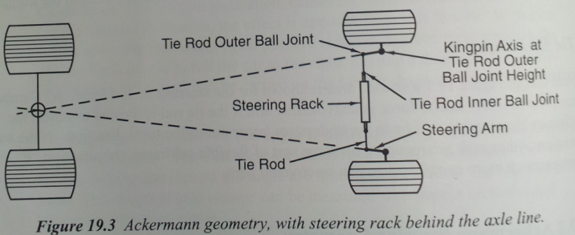

Figure : Basic Ackermann Steering Geometry

# Design of Major Components

## Battery System

Since the budget of the project at the time of writing this document is $5,500 there are severe limitations on the components that can be used in the battery system. The configuration that we have chosen will be designed to power one motor but more if more funding is acquired then the second motor controller will be wired in parallel with the first motor therefore the same voltage will be used. All that will need to be added is more capacity. This can be done by adding more batteries to the parallel bunch of batteries that are discussed later in this section.

Two types of batteries have been considered in the design of this vehicle. The first is a Lithium Polymer (Li-po) type battery. The second is a Lithium Iron Phosphate (LiFePO4). Different characteristics such as discharge rate, capacity, lifespan and different cost comparisons were taken into account during the design process of the vehicle. Lead acid battery characteristics are also mentioned in the comparison charts as a reference.

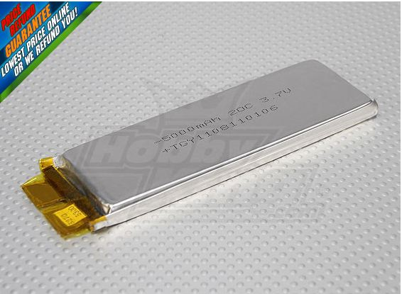

Figure : Li-Po Single Cell (10)

As far as discharge characteristics go the Li-po batteries have by far the highest. Discharge rates as high as 65C continuous and 130C in 10 second bursts can be achieved. With the LiFePO4 batteries a continuous discharge rate of around 10C with a peak discharge of around 15C. Lead Acid batteries can have even lower discharge rates than the LiFePO4 batteries.

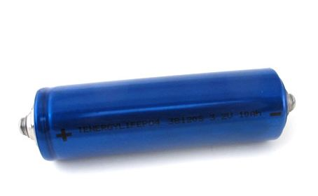

Figure :LiFePO4 Single Cell (11)

When one looks at the capacity of the battery types though another side of the story is seen. LiFePO4 batteries seem to have the highest available capacities. It is easy to find LiFePO4 batteries that have capacities of around 80Ah or more. When you look at the Li-Po batteries it is hard to find any that exceed 6Ah of capacity. Lead acid batteries lie in between the two types of lithium batteries but are far too heavy for the application we are designing for.

After further research on the BMS that will be used in the car it was decided that using the larger packs of batteries that are prewired would be too hard to implement. Therefore the team has decided to go with single cell Li-po batteries. The batteries are still 5Ah capacity batteries and only run around $9 a piece. For the configuration that the team wants to use there will be one accumulator that will have a combination of parallel and series wirings to achieve the required capacity and voltage.

In order to do a good comparison of different battery types all three types of batteries were chosen with the same charge capacity for equal comparisons. Figure 12 shows that the Li-po batteries have both the highest energy density and power density. Figure 13 shows another side of the story where the Lead Acid batteries are the cheapest but they have such low energy and power densities that they are not a viable option. The next highest after that is again the Li-po batteries. This has led the team to the conclusion that the Li-po batteries will be used unless a cheaper source of the LiFePO4 batteries can be found.

Figure : Mass Comparisons

Figure : Dollar Comparisons

The battery configuration that will be used will have 30Ah capacity but allow for further addition. The voltage that will be used is 72V. The way that this will be realized is shown in and consists of 6 cells wired in parallel to achieve the 30Ah capacity and this will be repeated 20 times in series. The reasons for this will be discussed later in the BMS section of this paper.

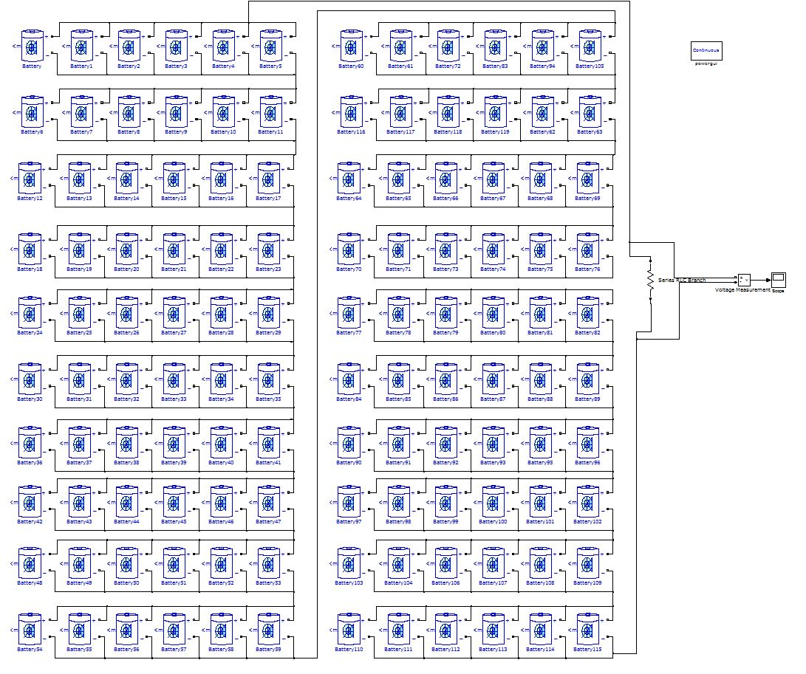

Figure : Battery Configuration

One more thing to note about the choice of batteries is safety. Because the Li-po batteries have such a higher discharge rate there is a much higher risk in using them. Li-po batteries have been known to combust when short circuited. Therefore much care will be taken in the wiring of the batteries. One of the pros of the LiFePO4 batteries is that they are not as combustible as the Li-po batteries making them the safer choice. These risks are covered later in chapter 5 of this document.

Capacitors as a method of absorbing regenerative breaking from the controllers will not be used unless the team is ahead of schedule next semester. The team already has a source of obtaining these capacitors by means of borrowing them from a team member so lead time on getting these and cost are not an issue. The regenerative breaking is not deemed as a critical component of the system at this time though.

## BMS Configuration

The two BMS that have been looked into for the vehicle are the Elithion BMS and the Orion BMS. There are pros and cons of both systems. The team can already make use of an Elithion BMS from the previous year’s vehicle. If the Elithion system was used then all that would need to be purchased is the cell boards for the vehicle. These cell boards are priced at around $10 each and different configurations of these boards will be discussed later in this section. The cons of using the Elithion BMS is that the software for the system is slightly dated and it does not measure as much data about the batteries as the Orion BMS.

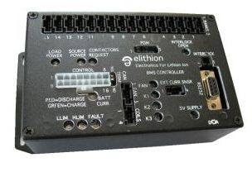

Figure : Elithion BMS Master Board (15)

With the Orion BMS a whole new BMS master would be required which can cost up to $1,100. Some of the pros of the Orion BMS though are easier programming, isolation fault detection built-in, much faster sampling rate (30ms vs. 600ms) and a few other small things. The cost of the cell boards seems to be less from their website and they offer a $200 educational discount but even with these it still vastly overprices the Elithion BMS. Since the budget for the project is so tight the decision to go with the Elithion system has been made.

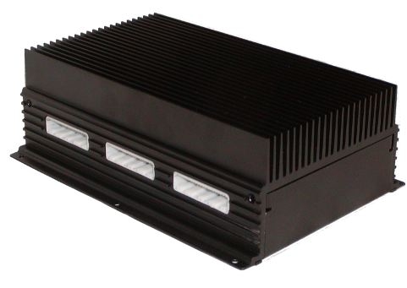

Figure : Orion BMS Master Board (16)

As stated previously the batteries will consist of 6 Li-po batteries in parallel repeated 20 times in series. The reason for this is because the Elithion cell boards can handle an unlimited number of batteries in series and only 1 cell is required for every parallel string. Therefore this design will only require 20 cell boards. If our design had 20 batteries in series repeated 6 times in parallel then we would need a whole 120 cell boards to measure each individual voltage. This difference is about 100 cell boards and at $10 a piece this design saves the project about $1000.

To recap the subject of the BMS a basic explanation of how a BMS works is given below. The BMS measures the voltage across each cell and can stop the charging of the batteries if the individual cell voltage gets too far off from the rest of the batteries. The reason this needs to be done is because there can be devastating consequences if Li-po batteries are in either under-voltage or over-voltage conditions. These consequences can include combustion of the batteries and cause a total system failure.

## Ground Fault Detection

The ground fault detection device that will be used in the vehicle is the A-ISOMETER IR155-2 made by BENDER group. This device is being provided to the team free of charge where the team only has to pay $25 shipping and handling in order to receive the item.

This fault detection device is made for unearthed DC systems and is rated from 0V all the way up to 800V. The A-ISOMETER measures the insulation resistance between the high voltage bus and the frame of the vehicle to make sure that a fault has not occurred. If a fault does occur then a signal is sent to the ground fault detection switch and the system is shut down.

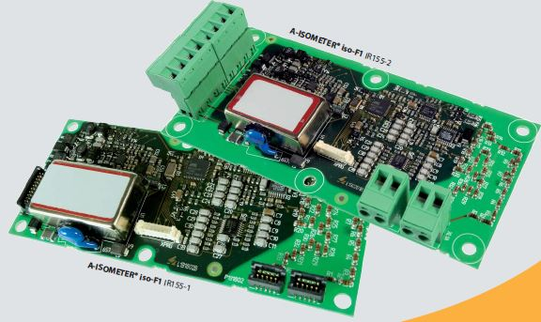

Figure :A- ISOMETER IR155-2 Fault Detector (17)

Below in Figure 18 the wiring diagram from the spec sheet provided by bender is shown

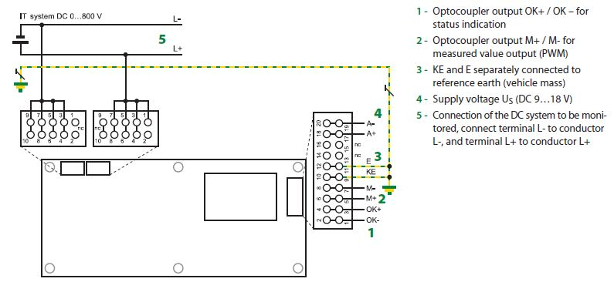

Figure : A-ISOMETER Wiring Diagram (18)

## Charging System

In the previous proposal the battery system was being designed with a 144V accumulator in mind. Since the team has decided to go with a lower voltage 72V accumulator a new charging system will be needed. Since the car will only have one battery pack though the vehicle will only need 1 charger. The charger that the team has chosen for the vehicle is the HWC4 Series charger with an output of 72V/30A and has a 220VAC input. This design also reduces the cost of the charger by around $200.

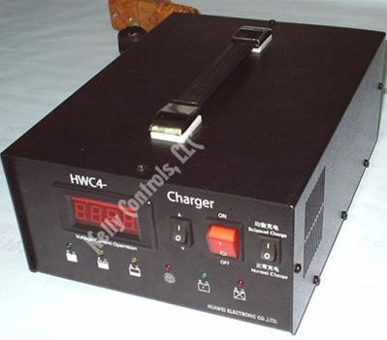

Figure : Battery Charger HWC4 72V/30A (19)

## Low Voltage Accumulator

The low voltage accumulator on the vehicle will consist of a single 12V lead acid battery. It will be used to power all of the sensors that are not attached to the high voltage circuit. The low voltage accumulator will also be grounded to the frame of the vehicle.

## Motor Controller

The motor controller is a Kelly KD72501. Figure 20 shows a modified schematic from Kelly Controls, LLC that reflects the setup that will be used with the Agni motor. Please keep in mind that while the schematic does not display it, the switch and both potboxes will be optically isolated.

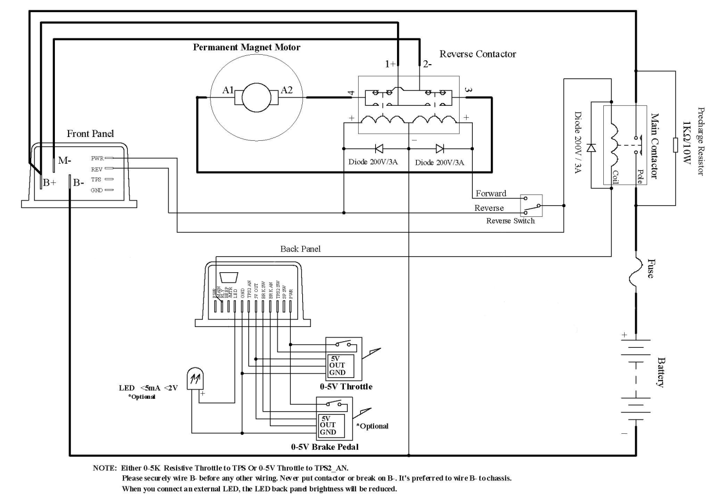

Figure : A modified schematic from Kelly Controls, LLC  
Courtesy Kelly KD User Manual

## Optoisolator Circuit

Figure 21 is a schematic of the optoisolator circuit used throughout the vehicle’s electrical system. This allows low voltage analog signals to be communicated with high voltage components. This particular circuit (below) is the one used for the throttle potbox. The red wire is the +5V line and the black wire is the relative ground to the red wire. The white wire is the variable voltage line. The circuit is based on the 4N25 optocoupler IC. This circuit is used for the throttle and brake potboxes as well any other components that are within the cockpit that communicate with high voltage circuitry. It should be noted that this circuit is not used for the signals that power the contactors as the contactors are a type of relay which does not require optical isolation.

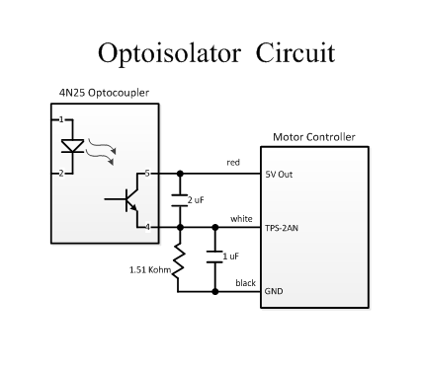

Figure : Optoisolator Circuit Used in the Electrical System

## Chassis

As mentioned previously, when considering the design of a system, component, or virtually anything, the goal of the design needs to be considered first and foremost rather than just using previous techniques because they are proven reliable. This exact perspective was used when designing the frame and several methods were considered primarily dealing with the different materials that could be used for the construction. These materials, in some cases, make the nature of the design and build process inherently different.

The material consideration was initially divided into two categories: all metal or a composite. The advantage to building the body from a composite material is that the chassis could potentially be very light and that the composite material would combine several duties that are usually handled by several components. It would not only replace the steel’s structural responsibility, but in addition, it would also serve as the floor pan and serve the duties of the body in terms of aerodynamics, aesthetics, and to protect the driver from debris. This structure is given the name of monocoque because it is all unified in to one piece, or at least the main structure is. In order to do this out of composite, it would have to be done out of carbon fiber as a result of the strength requirement. The most appealing was the carbon fiber and aluminum honeycomb combination due to its strength to weight ratio, an example of which can be seen in Figure 22 below.

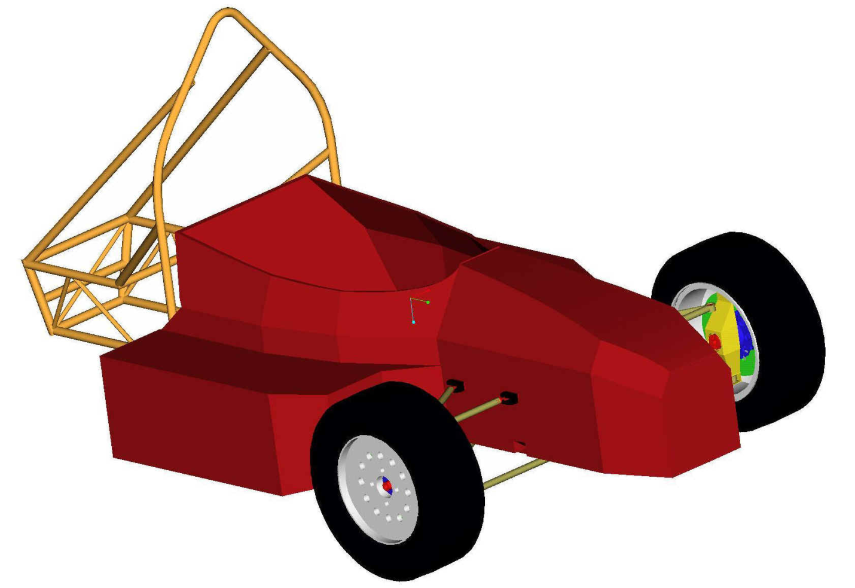

Figure : Composite Monocoque Chassis from

It would be very difficult for this to be made and expensive for it to be bought. Therefore, the consideration of just carbon fiber was taken into account and it was primarily decided that, as a result of inexperience with this material, that we could consider an all metal chassis. The motivating factors for this decision were governed by lack of experience constructing something of this nature, lack of knowledge regarding the strength of the material and the amount of time that this process would take. Since the strength of the chassis is of great importance for primarily safety reasons, it could not be guaranteed that, given the timeline, something suitable would be constructed with time left to perform testing.

The elimination of composite materials narrowed the options to an all metal chassis. According to the rules, certain items MUST be made of steel and, therefore, joining these two materials would involve a more in depth view and be more time consuming and given the short timeline and very limited number of team members, it was then decided to remain with all steel. This, of course then narrowed the selection process down to the type of steel. Research was done to examine the type of steel that other teams used and why and it was determined the 4130 chromoly steel alloy was the best because the weight increase of this alloy is so small that it is negligible and the strength gain is quite significant with its yield strength being nearly double of that of 1018 steel, which is the type of steel used as the minimum standard in the Rules document. The advantage of having a stronger material allows for the weight of the vehicle to potentially decrease because an equivalent or greater strength can be achieved be increasing the diameter of the tubing, which increases the moment of area and permits the wall thickness to decrease allowing for less material. The only limitations are the minimum wall thicknesses prescribed in the rules. These calculations can be seen on the attached pages in the appendix.

One of the main guiding factors to the design of the chassis is the fitment of components and the serviceability of the end product with respect to the components that it will house. The purpose of the chassis is to provide a structurally sound enclosure for the driver and the components used to operate the vehicle, as well as to provide mounting points for any external components; therefore, the main design goal is to ensure that the structure can fit the required components and without being able to physically test this, representative solid models must be created to test fitment to save time and cost during the actual building process. This can be a very time consuming process depending upon the level of detail included in the solid models. Although a great level of detail is not necessary, it can be advantageous to use when conducting a presentation in order to better describe a system or components. Realistically, the only detail required is the general shape and volume that the object will occupy and the mounting requirements for the part.

The chassis then needs to be thoroughly overviewed to compare against the requirements instated by the rules documents to correct any discrepancies. The chassis is continuously checked against the rules during the design process, but is most thoroughly reviewed once the chassis is close to being finalized. This will prevent any issues during the build and will ease the preparation for passing technical inspection. Additionally, a finite element analysis will be performed. This will analysis will assist in dictating where areas will need to be strengthened, or, possibly, even where frame members can be removed.

The last overview of the chassis design will be an analysis of the feasibility of the build. This is something that is kept in mind throughout the design process, but is analyzed more thoroughly at this stage. This essentially is an examination of the chassis in regards to whether or not it can be built using the tools available and the difficultly that this will impose on the builders to construct it as shown in the 3-Dimensional model as accurate as possible.

## Suspension

**Wheel Base and Track Width**

The minimum allotted wheel base for the competition is 60 inches. There is no set way to determine the actual needed wheelbase. It is set to the choice of the designing team. A shorter wheelbase, however, induces a greater lateral force on the rear wheels in a turn. As a result, an increased lateral acceleration during corner which will increase oversteer characteristics, causing sharper turns. To account for this, a proper wheel track is in need to be selected. Choosing a fairly wide track width has many advantages. Increasing track width reduces load transfer on turn entry resulting in tire loads being more evenly distributed. In doing so, this also improves the lateral acceleration capabilities and better acceleration on turn exit. When comparing our 62 inch wheelbase with the 48/44 front to rear track width with racing teams of formula SAE that out performed in past autocross events, our ratio of wheelbase to track width is within the same ‘ideal’ range.

**Front Suspension**

**FVSA**

The SLA front suspension consists of two control arms and a steering linkage to constrain the movement of the wheel. Designing the specific geometry of these components takes into account many parameters of wheel travel along with force transfers. While the static load case of the wheel characteristics may be functional for a straight line velocity, the real purpose of the suspension is to handle cornering forces. During cornering, the outer wheel experiences a greater lateral force due to changes in lateral acceleration as well as changes in left to right weight distribution from a neutral standpoint. The short upper control arm feature of this design minimizes camber changes due to this change in lateral weight distribution but does not reduce the body roll moment that the vehicle experiences. As a result, the lateral force difference between the left and right wheel still remains.

The first step is reducing body roll. With a roll instant center (RIC) location close to the ground, the non-rolling overturning moment is reduced. As the suspension deflects in the turn, the outer wheel travels upward and the inner wheel travels down. This affect called jacking, relocates the rolling instant center below ground. With a low enough static RIC location, the change from above to below ground causes the vehicle chassis to deflect down in thus reducing the rolling moment at the center of gravity.

With the difference of lateral forces between the inner and outer forces still remaining, the use of an anti roll bar setup is introduced. As seen in Figure 23 below, both front push rods are connected by a linkage. Rotating from the center of this linkage, the higher lateral force on the outer wheel is transferred to the inside. The overall effect of this is balancing the lateral forces between the two wheels and reducing traction losses experienced by the inner wheel.

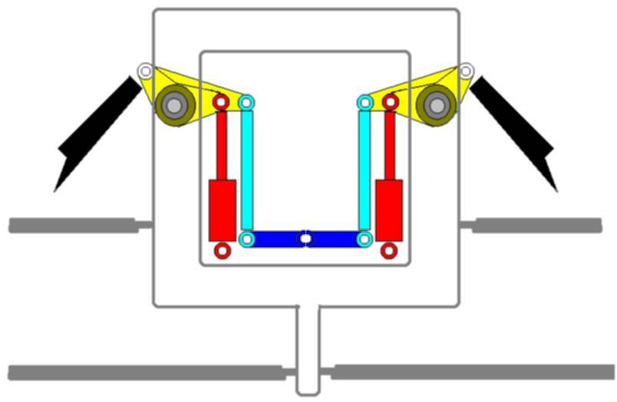

Figure :Push-rod anti-roll bar linkage

From the front view, the upper and lower control arms reach a point called the instant center. This length from the instant center to the center of the contact patch is called the front view swing arm (FVSA). The intersection of the instant center to the centerline of the contact patch from both sides will overlap at some point. This point is the determined location of the rolling instant center as seen in ((figure X)). Thus, when designing the location of mounting points on the chassis and wheel hub, the desired RIC location needs to be considered. Another aspect that goes into the control arm geometry is the camber change rate. With a short FVSA length, the camber changes are larger than desired. To achieve small camber gains and losses, the FVSA length should be as long as possible while also achieving the desired RIC. Once the optimal FVSA length is found, another aspect to camber is to set the static camber angle slightly negative, about one to two degrees. With minimal camber change, this angle will always be negative which is desired to improve handling.

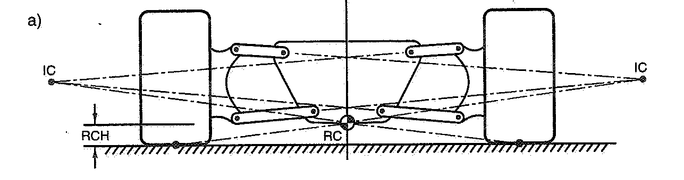

Figure :Roll Center Construction

The last feature of the FVSA is the scrub. The scrub is the resulting lateral motion relative to the ground during vertical wheel travel. To minimize the effect of scrub, the instant center of the front view is located on the ground. This is another parameter to consider when the final geometry of the front control arms is designed. By locating the instant center at the ground plane or just above it, see figure X, minimum scrub will be achieved while maintaining the previously discussed geometry requirements.



Figure : Scrub as a Function of IC Height

**SVSA**

The side view swing arm (SVSA) contributes to the anti-features of the vehicle. With longitudinal forces and motions in the fore and aft direction, these features will control dive, lift, squat, and wheel path. From calculations of desired features, the slope of the control arms is then determined. For a rear wheel drive vehicle, Anti dive prevents weight transfer to the front during braking application, controlling the pitch of the vehicle. Although front weight transfer is desired, weight still needs to be sufficient in the rear to maintain traction in the rear. With the addition of anti dive in the front suspension, it may change the mechanical trail and or caster angle with bump travel which is undesirable. So the optimum SVSA for the front is placed at infinity, which correlates to horizontally parallel control arms and zero anti features in the front design, leaving these effects to be accomplished in the rear suspension.

Mechanical trail, as defined in the below, creates a moment acting on the kingpin axis. This moment produces a self centering effect on the kingpin axis at speed. For manual steering, the mechanical trail/caster angle should be reduced to almost zero. The result in keeping this value at or close to zero prevents forward or backward movement of the tire.



Figure : Front Suspension Packaging

**Rear suspension**

**FVSA**

The SLA rear suspension consists of two control arms and a toe link to constrain the movement of the wheel. Similar to the front suspension, the design of the specific geometry takes into account many parameters of wheel travel along with force transfers. Starting with the roll instant center location, for rear wheel drive applications, the best acceleration out of a turn is achieved with a lower rear roll instant center than the front’s RIC. With the front design resulting in a RIC at or just above the ground plane, the only options is to have the front and rear RIC even or place the rear instant center below the ground. The effect of locating the RIC below ground is the downward movement of the rear chassis. This in turn increases the traction of the rear tires. The difference in lateral forces between inner and outer wheels still remains at this point. To keep traction on the inside wheel, a similar set up to the front anti roll set up is used to produce a left to right load distribution that is closer to even.

Similar to the front, the FVSA length should be adequately long to reduce the camber change rate. With the same methods used on the front, the rear control arm geometry can be determined by locating the instant centers and RIC. Furthermore, slight negative camber angles in the rear are ideal; approximately a half to one and a half degrees is desirable for optimum handling.

**SVSA**

The rear suspension will control the pitch of the vehicle. Calculated anti lift and anti squat will control the vehicle as the weight is transferred front to rear. During breaking the anti lift in the rear will limit weight transfer to the front tire. At the same rate, under heavy acceleration, the anti squat will reduce the weight transfer to the rear.

**Overview of progress**

Understanding all of the features to account for when designing a suspension system is relatively complex. The suspension for this vehicle is making progress with final ideal location selections of wheel base, track width, rolling instant centers, instant centers and scrub, along with ideal handling camber angles. The next step is to sketch the front view swing arm and side view swing arm of the front and rear for the final geometry points and plug them into Adams-CAR. From this point we can test out our calculations and make single modifications to see what positive changes we can achieve. When the final simulations are completed, the Suspension will be finalized to fir the chassis. Slight modifications to the chassis may take place in order to accommodate the best suspension design.

## Braking

The design of the brake assembly will be left to Sam Risberg. Measurements of the brake lines from the previous year’s car will be taken to ensure there is enough length to compensate for the new chassis. The calipers will need to be 3D modeled to the hub and make sure there are no clearance issues with any sprung masses or unsprung rotational masses. The rotor should fit in either case and will just require to be mounted to a hub with a proper bearing that will allow for smooth operation. The hub will be designed to compensate for the caliper, but brackets can always be made to allow filament.

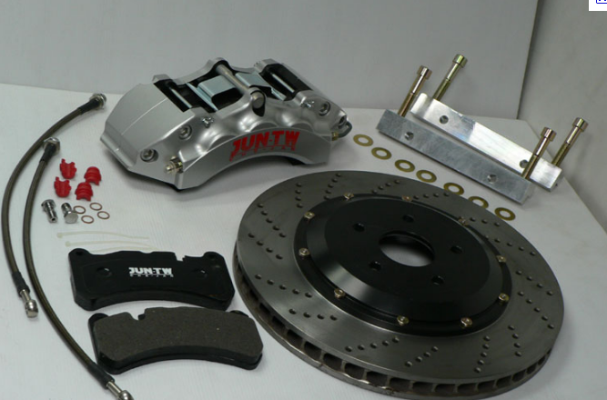

Figure : Entire Hub (Brake Assembly)

## Steering

Steering will be simplified to the easiest version of understanding. This will be rack and pinion as shown below in Figure 24. The rack will need to be out of the way for any moving parts or feet. The tie rod will move with the wheel and will also need to be measured at extremes to ensure easy and bind less steering. The steering wheel is an important part of the system, because it is what the driver is touching. The wheel will have to be inside the roll center of the car and allow for quick removal.

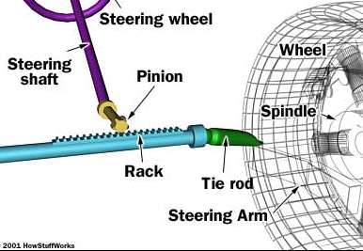

Figure : How a Rack and Pinion Works

# Schedule

# Project Schedule Pic.JPG

# Budget Estimate

The needed materials for the completion of the vehicle have been revised. Below they are broken down into individual components. The budget is organized into a lesser list of items that would be needed for a one-motor design and a greater list of items that would enable two-motor operation. In our proceeding purchases we will be ordering parts that will be used in either case and constructing the vehicle in a manner that could accommodate a second motor if we could afford it later. In this way we are not committing ourselves to either design and we waste no money switching designs later. However, if the funds cannot be found later, we will have a fully functional, one-motor vehicle.

|  |  |  |  |
| --- | --- | --- | --- |
| **Mechanical Budget** | | | |
| **Items Needed to complete the vehicle:** | | |  |
| **Item** | **Quantity** | **Price/Qty** | **Total/Item** |
| Steel Tubing | 162 | $8.85 | $1,433.70 |
| Rod Ends (Heim Joints) | 30 | $8.00 | $240.00 |
| Wet Tires | 5 | $208.00 | $1,040.00 |
| Sheet Metal | 3 | $284.80 | $854.40 |
| Brake Pads | 4 | $28.50 | $114.00 |
| Misc. Costs (Brake fluid, seals, gears/sprocket & chain, bearings) |  |  | $600 |
|  |  |  |  |
|  |  | **Total:** | **$4,282.10** |
|  |  |  |  |
| **Items desired for a better 2WD car:** | | |  |
| **Item** | **Quantity** | **Price/Qty** | **Total/Item** |
| Penske Shocks | 4 | $675.00 | $2,700.00 |
| Suspension Springs | 4 | $45.00 | $180.00 |
| Rims | 10 | $113.00 | $1,130.00 |
| Conduit | 100 | $3.00 | $300.00 |
| Brake Lines (Steel Braided) | 6 | $52.32 | $313.92 |
| CV Axles | 2 | $72.78 | $145.56 |
|  |  |  |  |
|  |  | **Total:** | **$4,769.48** |
|  |  |  |  |
|  | **Grand total:** | | **$9,051.58** |

|  |  |  |  |
| --- | --- | --- | --- |
| **Electrical Budget** | | | |
| **Items Needed to complete the vehicle:** | | |  |
| **Item** | **Quantity** | **Price/Qty** | **Total/Item** |
| HV Accumulator | 120.00 | $ 10.00 | $1,200.00 |
| HV Wiring | 100.00 | $ 4.00 | $400.00 | * May be less since only using 1 motor |
| Charger | 1.00 | $ 500.00 | $500.00 |
| BMS Cell Board | 20.00 | $ 10.00 | $200.00 |
| Conduit | 15.00 | $ 3.00 | $45.00 |
| LV Accumulator | 3.00 | $ 50.00 | $150.00 |
| ECU | 1.00 | $ 150.00 | $150.00 |
| RPM Sensor | 4.00 | $ 40.00 | $160.00 |
| Throttle | 1.00 | $ 150.00 | $150.00 |
| Brake | 1.00 | $ 150.00 | $150.00 |
| Master Switches | 3.00 | $ 40.00 | $120.00 |
| Ground Fault Detector | 1.00 | $ 100.00 | $100.00 |
| "Fuel" Gauge | 1.00 | $ 60.00 | $60.00 |
| Speedometer | 1.00 | $ 60.00 | $60.00 |
| LV Wiring | 150.00 | $ 0.20 | $30.00 |
| State of Charge Sensor | 1.00 | $ 40.00 | $40.00 |
| Forward/Reverse Switches | 3.00 | $ 12.00 | $36.00 |
| Key Switch | 1.00 | $ 30.00 | $30.00 |
|  |  |  |  |
|  |  | **Total:** | **$3,581.00** |

# Overall Risk Assessment

The quality and successful completion of this project requires that we forecast and manage any risks and complications that would stall the project’s forward movement. As with any project involving new designs there are risks that plans made will not work and may need revision. Recognizing this possibility in advance will allow us to be ready for it and take these problems in stride. The following is a breakdown of foreseeable or possible complications.

## Technical Risks

Technical risks are design, integration and project completion risks that may impact the success of the project. In our design, these can come from systems not working as intended, or not working within the acceptable guidelines of the competition. In some ways, a car made successfully for personal use may not meet requirements for competition use. Acknowledging that we are constructing this vehicle to eventually compete in this competition successfully, we must constantly assess whether it is following competition requirements that assure it fulfills an acceptable design, maintains a high level of safety, and performs on par with other vehicles of its type.

### Technical Risk 1: Meeting Competition Guidelines

Description

Meeting competition guidelines is a necessary aspect of this vehicle’s design. We are obligated to follow the required dimensions, safety traits, and miscellaneous limitations of the competition.

Probability: < Very Low, Low, Moderate, High, or Very High>

It is almost guaranteed that this will have an impact on multiple decisions we make in our project, but proper management will affect how severe its affect will be.

Consequences: <Minor, Moderate, Severe or Catastrophic>

The longer unacceptable traits are allowed to remain in our ongoing design, the more problematic it will be to address them. If flawed or unacceptable designs are continued and built up further, then instead of having to restructure one component of the vehicle we may have to reconfigure whole systems.

If the risk is never found and addressed then it could result in the disqualification of our vehicle before it even rolls onto the track, which would not only bring shame on our school but also result in our efforts being wasted.

Strategy

In order to find these problems before they become deeply integrated into our design, we will inspect designs at many critical points in the planning and throughout the realization of the vehicle. We have developed detailed and comprehensive technical inspection sheets to successfully test the designs for adhesion to the competition guidelines.

Describe your strategy to manage this risk. Remember the general categories of strategies that you can use: avoidance, minimization and contingency plans.

### Technical Risk 2: Failures of Safety

Description

Beyond the safety requirements of the competition, it is necessary that the vehicle is constructed in a manner that acknowledges the inherent risks of dealing with certain vehicle components during the assembly and operation of the vehicle.

The battery system in particular must be handled in a very careful and knowledgeable way to avoid several problems. Examples of these problems include risk of shock that could result from failure in components such as the ground fault detector, which mitigates this concern by shutting down electrical systems if a fault is detected. This failure could stem from other components as well if, for instance, the low voltage accumulator which services the BMS and the ground fault detector was not functioning properly and resulted in a functioning ground fault detector that was simply not active.

The batteries themselves are fairly volatile and if they are not handled properly then they can fail in other dangerous ways. If they are overcharged or over discharged then they can combust into a not so healthy “ball of fire.”

The safety risks concerning this vehicle are numerous, with some concerns being more or less common sense, such as the proper way to use power tools, while others may not be common sense. Those people that are working on the vehicle need to understand what could go wrong and how to properly avoid injury.

Probability:

The probability of failures in safety is a function of how educated those working on the vehicle are to the proper handling of components.

Consequences:

The consequences of failures in safety range from injury to death, and may also result in destroyed materials if components are improperly handled to breaking point.

Strategy

Only those that were most instrumental in the design of the electrical system will participate in the construction and management of these systems. In this way, the people exposed to this risk have the greatest knowledge of the risk and how to avoid any injury or problems. Anybody working on any component of the vehicle will need to know how to complete tasks before even picking up a wrench. Tinkering and experimentation must be minimized.

### Technical Risk 3: Supplier Specifications for Components

Description

There is some risk that the parts we receive from suppliers may not be the exact components we intended. This could come from unclear communication or a less than professional supplier.

Probability:

If we are careful, thorough, and deal with reputable suppliers then this should not be that likely.

Consequences:

If this happens then we would have to reorder parts, and we could possible end up wasting money if a full refund was not granted. This could harm our budget and schedule.

Strategy

We must order parts early enough that complications will not stall forward progress on the vehicle. We must deal with reputable suppliers and not place blind trust in promises until they are actually realized. When we deal with suppliers we must make sure to be clear and thorough to avoid miscommunication. If we deal with suppliers that have been dealt with before then the probability of surprise will be minimized.

## Schedule Risks

Scheduling is very important for achieving many goals of the project and cannot be overlooked. If goals are not reached in the schedule time, negative consequences will arise and affect the project being completed on time. Different measures will be taken to make sure each step is achieved in the schedule time. Before the schedule can be made though, a few things need to be taken into consideration. The team needs to establish the tasks that are needed to complete the project, the precedence relationship of the tasks, and the expected duration of each task. By knowing these things the team will be able to use different tools such as a Gantt chart or Critical Path Method to assist their scheduling needs.

### Schedule Risk 1: Full Completion of the Vehicle

Description

There are multiple components of the vehicle that need to be assembled in coordination with one another. These tasks require different amounts of time to be completed. The order in which they are done is also very important to the project, as certain steps have to be done before starting the next. Many components of the vehicle are being worked on at the same time. All these factors contribute to a scheduling risk of completing the project.

Probability

The probability that this risk will occur is high. This is because of how complex the design is and how many people are working on it. If team members, individually or collectively, fail to meet deadlines the whole project will be affected.  The precedence in which each component needs to be finished will increase the probability of the risk, as one member may not have their task finished which could result in not being able to start another.

Consequences

The consequence of not completing the project in the scheduled time is catastrophic because the team would not be able to compete in the competition.

Strategy

The strategy will be to use a Gantt chart to monitor each task individually and push deadlines up to ensure enough time for completion of the vehicle and testing. The Gantt chart will give the team a great understanding on when each component will be completed. It will show start and end dates for each one along with the expected duration. If a component is not on schedule to be completed, more attention will be given by additional team members to ensure it meets the deadline.

### Schedule Risk 2: Receiving Parts

Description

Ordering parts for the vehicle takes time. The team must take this into consideration when ordering and receiving parts required for the project. This also ties into the funding for the project as the team’s budget may change, giving them the opportunity to purchase more parts to improve the design.

Probability

The probability that this will occur is high because the team could receive more money at a later date and want to order more parts. The order process could take a very long time and delay the project.

Consequences

Consequences are severe for not ordering parts on time. This will affect the whole project in terms of completion and delay testing. Shipping could also take longer than expected and planned.

Strategy

The strategy will be to have all parts ordered before Christmas break to allow enough time to receive them. The team will use that as a deadline, using whatever funds they have at the given time. If more money is received, the team will look into improving the design by ordering more parts.

### Schedule Risk 3: Obtaining Funding

Description

The timing of obtaining funds affects the project. Fundraising efforts will determine the design of the vehicle, so it essential to have all funds by a certain deadline. This runs in coordination with another scheduling risk of how long it takes to obtain parts.

Probability

The probability of this risk is low in terms of how it affects the overall project because it is possible to compete in the competition with the given funds.

Consequences

The consequences of this risk are minor in terms of completing the overall project, however are severe in doing well in the competition. The project completion is possible with the current funds but more funding would increase their chances of doing well.  However if donations are received after a set deadline, improving the design may not be possible without affecting the schedule of completing the project.

Strategy

The team's strategy is to have a set deadline in which the team finalizes the design according to their budget. If more money is received after this deadline the team will look into improving the vehicle but may not be able to.

### Schedule Risk 4: Changes in the Design

Description

Any change in the design, big or small, will affect when the vehicle is completed.

Probability

The probability of changes in the design are very high because the budget is not finalized yet and more funds can still be received. Small changes are likely as problems may arise.

Consequences

Consequences of this risk range from minor to catastrophic in terms of scheduling. Planning can minimize these consequences but problems may arise that are unexpected and take time to fix.

Strategy

The strategy is to plan for everything that may affect the design. The team currently has a design in place with the current budget and another if more funds are received.

## Budget Risks

Budget risks are risks that may produce budget overruns. These can include additional support costs, unexpected material or equipment costs, component or system failures, underestimation of costs

### Budget Risk 1: Overextension

Description:

There is a risk that if we try exceeding the capabilities of our funds we might end up with an uncompleted vehicle.

Probability:

With constraint and proper planning this could be made unlikely.

Consequences:

If all of the parts were not able to be afforded then we could have a fractionally complete vehicle, unable to compete in competition. If we redesigned instead, then certain attributes of the vehicle could be compromised.

Strategy

With fundraising we may be able to afford making a better vehicle. Until funds are secured we must proceed with plans that allow for upgrades or a completed, even if less powerful, vehicle. We must make sure that plans are thoroughly conceived before rushing into purchases.

### Budget Risk 2: Hidden Costs

Description:

If we are not able to see all of the future costs that will be accrued in the construction of this vehicle, then we could possibly overestimate the reach of our budget. These may include shipping charges, taxes, unseen components or material, and fines.

Probability:

It is highly probable that there are some costs that we have not realized yet, but the amount of these costs is most likely small.

Consequences:

If these costs are higher than expected, we will have to secure more funding or else the vehicle may not be able to be completed. The less reserves kept, the more any team member going to competition would have to pay out of pocket.

Strategy

With thorough planning and correspondence with advisors and former project members we can get a better idea of less apparent costs that we may run into. We should keep a cushion of funds for miscellaneous expenses in the construction of the vehicle.

### Budget Risk 3: Component Failures

Description:

If components are broken during construction or testing then these will equate to wasted funds.

Probability:

It is possible, but with responsible management could be confined to only small replaceable parts.

Consequences:

If components fail whether through defect or abuse then it could delay or bankrupt our project. In the case of defect, hopefully a free replacement could be received in a timely manner. In the case of some components, injury could result.

Strategy

Those handling expensive components especially need to have a certain level of understanding about components. Handling will be kept to a minimum and test driving of the vehicle will be done in a cautious manner.

## Summary of Risk Status

The risks described comprise a very thought out and attentive list of possible hazards and complications to this project. We feel that this list is near comprehensive for items with any significant probability or consequence. Our strategies as outlined in these sections should be sufficient to minimize and control these events from affecting the quality or completion of our project.

The only thing outside of our control or planning is our budget. How we manage our budget will be responsible and forward-looking, but if additional funds are not found then there is only so much we can do for the quality and completion of our project. As outlined in the budget estimate section of this report, the extra funds are not that sizeable and we are confident they will be forthcoming.

As for any other risk we have identified, the main strategies seem to be attentiveness and education. The more we acknowledge and learn about certain risks, the more they will be inside of our control. We feel like we are thoroughly up to the task and the overall impact of these risks will be minimal.

# Conclusion

As can be seen in the sections above, the vehicle is comprised of many systems and subsystems that vary in complexity. Although when designing these systems, it is often easy to become so focused on the system itself that the method of integrating it into the vehicle is often neglected, it is a crucial consideration since these individual systems must eventually be integrated to produce a working vehicle.

As a result of continuously meeting and communicating with each other, the members came to realize this early on, which avoided many problems that would have otherwise arisen, possibly resulting in major design changes. There are, of course, many systems where the inter-relationship is very apparent, but, in those that are not, communication was essential, along with the design approach mentioned previously mentioned in this paper. Even though the design method for each system is different, the initial approach for each consisted of a deep consideration for the system’s goals and the various ways to create the design in a practical manner.

The team members have done this for this project and are finalizing the designs to prepare for the upcoming build and assembly. The team members have also tried to work well in an interdisciplinary setting. Though it has been challenging thus far much progress has been made.

References

1. "2012 Formula Hybrid™ Rules." Thayer School of Engineering at Dartmouth, 25 Aug. 2011. Web. 19 Oct. 2011. <http://formula-hybrid.org/pdf/Formula-Hybrid-2012-Rules.pdf>.
2. A- ISOMETER IR155-2 Fault Detector

See attachment in appendices called GFD

1. A- ISOMETER IR155-2 Fault Detector

See attachment in appendices called GFD

1. BMS Orion
2. BMS Elithion.com
3. Cloud electronic.com
4. http://www.cloudelectric.com/product_p/bc-hwc4-72v-fslash-30a.htm
5. http://elithion.com/products.php
6. "FAMU-FSU COLLEGE OF ENGINEERING FSAE SENIOR DESIGN." *FAMU-FSU College of Engineering :: Welcome*. Web. 30 Nov. 2011. <http://eng.fsu.edu/me/senior_design/2003/team1/>.
7. "HowStuffWorks "How Car Steering Works"" *HowStuffWorks "Auto"* Web. 30 Nov. 2011. <http://auto.howstuffworks.com/steering2.htm>.
8. J.A. Marin, J.E. Armstrong, and J.L. Kays, “Elements of an Optimal Capstone Design Experience,” Journal of Engineering Education, January 1999, pp. 19-22.
9. Li-po Batteries

http://www.hobbyking.com/hobbyking/store/__18560__Turnigy_5000mAh_1S_20C_Lipoly_Single_Cell_.html

1. LiFePO4 Batteries
2. http://www.orionbms.com/
3. Milliken, William F., and Douglas L. Milliken. *Race Car Vehicle Dynamics*. Warrendale, PA, U.S.A.: SAE International, 1995. Print.
4. *Performance Brakes - Brake Pads, Brake Rotors and Brake Kits*. Web. 30 Nov. 2011. <http://www.brakeworld.com/>.
5. Stone, Richard, and Jeffrey K. Ball. *Automotive Engineering Fundamentals*. Warrendale, PA: SAE International, 2004. Print.

# Appendices

**Please see the reference the following attachments:**

The first set of attachments includes the calculations for the usable wall thicknesses that are distinguish by the heading for three primary sections. These were done in MathCAD and are used for justifying the deviations from the standard dimensions provided in the rules.

The second set of attachments shows information regarding the A-ISOMETER IR155-2 ground fault detection device.